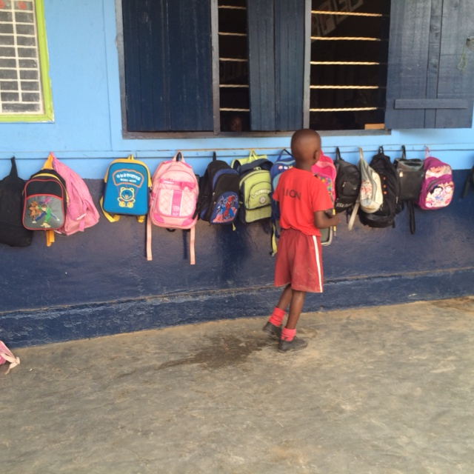
Safeguarding Against Sexual Exploitation and Abuse and Sexual Harassment (SEAH) for aid organisations delivering programmes to assist countries affected by COVID-19
Image credit @Social Development Direct

The risk of Sexual Exploitation and Abuse
and Sexual Harassment (SEAH) is likely to continue to increase in the coming months during the COVID-19 pandemic and response. Evidence from previous pandemics shows that secondary impacts can lead to changes in community behaviour and mobility, greater gender and social inequality and weakened service provision creating conditions that increase the risk of SEAH. It is therefore important that international safeguarding standards are prioritised and maintained as part of the COVID-19 response, with a focus on those who are most likely to experience SEAH. This guidance note has been developed to support civil society organisations (CSOs), the private sector and other stakeholders in the aid sector to take appropriate action to prevent and respond
to SEAH.
Who is most at risk of
experiencing SEAH?
Although contexts vary, SEAH takes place where individuals have an opportunity to abuse their power and is therefore primarily experienced by those that are already disadvantaged in a community. Women and girls are disproportionately affected by SEAH in the aid sector. However, other groups that face discrimination in communities are also at higher risk of experiencing SEAH, such as people with disabilities, lesbian, gay, bi- and transsexual (LBGT+), migrants, and girls and boys.
Women, men, boys and girls belonging to ethnic, linguistic, indigenous or race minorities are frequently subject to discrimination, stigmatization and marginalization and violations of their rights including denial of access to services, subsistence activities and security, which may also include SEAH. However, there is little research that currently explores this link. SEAH against men is particularly under researched.
Individuals that experience multiple forms of discrimination, such as adolescent girls with disabilities, boys living in refugee camps or transsexual women are at greater risk.
Loss of livelihoods and lockdowns due to COVID-19 will impact hard on communities and result in increasing marginalisation of those that are already vulnerable. In contexts where cash benefits or aid distributions are introduced to support communities, this can lead to increased power imbalances between the provider and recipient, which increases the risks of SEAH.

Groups most at risk of SEAH during the COVID-19 pandemic
Women  and Girls | Women and girls are at an increased risk of SEAH where they are reliant  on aid to survive, making them vulnerable to being forced to trade sexual services for access to goods and services. Women who are working on  the healthcare response are also at higher risk of SEAH, such as rape and sexual harassment, perpetrated by colleagues and patients. Sex workers, women heads of households and poor women are particularly at risk of SEAH by aid workers.
People with disabilities | People living with disabilities that are dependent on CSOs or other service providers are more likely to experience SEAH. Individuals that require assistance with personal care or whose speech and communication are affected by their disability are at particular risk, as are women and girls with disabilities. People with disabilities are less likely to recognise SEAH as an abuse of their rights, or to know how to report it; as a result, they may experience the abuse for longer. People with mental health problems  which are not considered a disability may also be more vulnerable.
Girls and Boys | Girls, and especially adolescent girls, are at risk of SEAH due to the combination of gender and age discrimination and may be seen as easy targets for transactional sex. Boys, especially those that are poor or are living in refugee or other types of camps, can also be targeted and may be less likely to report due to stigma associated with SEAH against boys. Measures to prevent the spread of COVID-19 may result in girls and boys being separated from their caregivers due to quarantine requirements or severe illness/death, leaving them at higher risk of different forms of SEAH, including by aid workers.
LGBT+ | LGBT+ communities frequently face negative attitudes, discrimination or outright denial of access to services by service providers, including by CSOs. This may lead to individuals identifying as LGBT+ being sexually exploited in order to access goods and services, especially vital services such as food aid and healthcare.
Individuals that experience multiple types of discrimination | Individuals that experience multiple forms of discrimination due to gender, age, sexuality, poverty, race, ethnicity, migration status, disability and religion are more likely to experience SEAH. The more overlapping discriminations a person experiences, the higher the risk of SEAH when s/he interacts with the aid system.
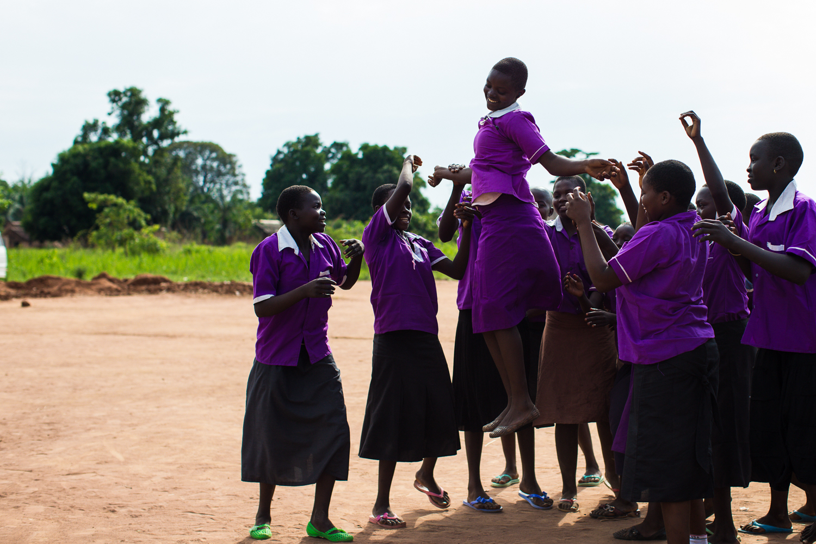
Image credit @MKCoursin

What action should organisations take to prevent SEAH during
COVID-19?
- Continue to work to implement recognised international safeguarding standards with a specific focus on the risks raised by COVID-19. As the risk of SEAH is increasing in the current context, it becomes more important that organisations review and make sure they continue to implement their safeguarding procedures in situations where international staff have been drawn-down and more reliance and oversight is placed on other types of actors. Vetting, signing of codes of conducts and mandatory training and supervision must continue for all new staff, contractors and volunteers and take place before they can start working despite the pressures to deploy staff quickly. Regular training must also continue for staff, and clear communications provided to ensure they continue to prioritise implementing safeguarding procedures despite heavier than usual workloads and urgent humanitarian priorities.
- Support female staff to take on leadership positions as part of your organisation’s response. Including more women in frontline and management positions is likely to increase awareness and monitoring of SEAH issues and reduce overall risk. Due to the pandemic, women may have increased family responsibilities, so consider and consult around what additional support for female staff might be needed.
- Identify new risks due to COVID-19, including both online and offline SEAH. This should be done based on a gender and social inclusion analysis of who is most at risk of SEAH in a given context. It is also important that for each programme/activity an analysis is done to understand the SEAH risk factors and where the biggest differences in power are, for example where goods/cash are being distributed or where a workforce is primarily male, as these scenarios increase the likelihood of SEAH.
- Design/adapt projects together with communities that are being supported as much as possible, taking care to include marginalised groups, particularly women’s rights organisations.
It is particularly important to understand SEAH risks for those most at risk and make sure activities and reporting mechanisms are designed to be accessible. While in-person meetings might not be possible, phone consultations with local activists or organisations can be used instead.
- Coordinate with other agencies working in the same sector including with the Inter-Agency Protection from Sexual Exploitation and Abuse (PSEA) Network (if present). This cooperation is time-consuming for smaller organisations when under pressure with stretched resources. However, failure to coordinate leads to duplication and/or a lack of knowledge about available protection and reporting resources and survivor referral systems. If there is not an existing Inter-Agency PSEA network, scope and coordinate with other relevant networks e.g. Child Protection or Gender-Based Violence (GBV).
- Make sure your organisation has an up to date list of referral services available for adult and child survivors of SEAH and that this is continuously updated based on Government/PSEA network measures to address COVID-19, which may also result in resources being diverted away from services not directly related to COVID-19. Service mappings need to include medical support (Post–Exposure Prophylaxis (PEP) to prevent HIV, Clinical Management of Rape, emergency contraception as well as wider treatment of injuries), psychosocial support, shelters or other places of safety, legal support and law enforcement. Coordinate with other stakeholders (such as the GBV or Child Protection sub-clusters or networks) to see if others have already done this and can share the information with you. Remember to consider the needs of both male and female survivors of SEAH.
- Ensure communities, households and individuals are well-informed of the referral services and where and how they can access them. In addition, efforts should be made to drive home the message that all humanitarian services are or should be free of charge, with posters at service points carrying said message, which should help limit demands for sexual favours in return for services.

- Assess the risks of remote management and supervision and assess the reliability of information you get (who is providing it - community leaders, your own staff, new partners?). Consider how you can be alerted to and monitor signs of SEAH happening in communities. More of your organisation’s work may be done online and on social media platforms where the boundary between professional and personal communication can become blurred. Provide clear guidance for your staff on what the appropriate etiquette is online and what they can and cannot do when interacting with community members online.
- Use non-stigmatising language and actively address harmful stereotypes and stigma that may develop in communities affected by COVID-19. Discrimination against individuals who have contracted COVID-19 or are associated with COVID-19 can lead to a reluctance to report SEAH or loss of livelihoods/support networks and may lead to individuals turning to sex work to survive.
What actions should organisations take to ensure reporting of and response to SEAH during COVID-19?
- Support survivors of SEAH and prioritise their safety even during lockdowns and strive for a survivor-centred approach. Depending on the circumstances, it is important to try to establish safe, confidential and direct contact to know the wishes of the survivor. Assistance may be needed from other agencies and /or the authorities to ensure the survivor is taken to a safe place if needed, to access referral services and for assistance if the report is to be investigated. This is also why it is important to keep an up to date service mapping.
- Support staff to manage their physical and emotional wellbeing, recognising that the stress of dealing with COVID-19 and lockdown may deter some people from reporting their experiences of SEAH. Colleagues may also be less able to recognise signs of inappropriate behaviour, and staff that have experienced SEAH may feel that their own experiences are not worth reporting in the context of overwhelming global needs due to COVID-19. Therefore, ensure proactive messaging around the continued prioritisation of staff and beneficiary safety and well-being, and that reporting is always going to be treated as a top priority.
- Review and adapt reporting mechanisms making sure they are accessible to those that are most likely to be affected by SEAH. The effects of the pandemic in communities will continue to change, so regular scenario planning and updating is useful to support preparedness and assess various options. Reporting mechanisms must be adapted to make sure that they remain accessible to women and girls, as well as other groups that may have difficulty accessing information, such as individuals with disabilities or other groups subject to social exclusion. Varied communication channels should be used to inform all parts of the community about what behaviours they can expect from aid agencies. Face to face with social distancing, radio, TV, social media, mobile phones, SMS, print (translated and accessible) should be considered, as well as messages delivered with aid. Evidence points to female voices being more effective in conveying these messages. Try to align your organisation’s reporting mechanism to others as much as possible to avoid confusion for community members.
- Assess reports of SEAH to identify what action to take and when, and keep the plan under regular review. Reports received should be acted upon despite lockdowns or other constraints. Case management decisions on risk should be made at each step of the investigation to decide whether
it is safe or feasible to conduct an investigation directly or remotely. A phased approach may be appropriate e.g. a desk study can take place first and if confidentiality can be guaranteed, interviewing can be undertaken either through a trusted partner or by phone. If at any stage the safety, wellbeing and health
of any of the parties to the investigation (survivor, subject of complaint, witnesses/ investigator) are compromised, the investigation should be put on hold, a revised risk assessment conducted and a decision taken as whether to adapt/continue or discontinue the investigation.

Suggested further reading
The Core Humanitarian Standards Commitment to PSEAH during COVID-19 https://www.chsalliance.org/get-support/article/seah-in-the-covid-19-response/
IASC (2020) Interim Technical Note: Protection from Sexual Exploitation and Abuse (PSEA) during COVID-19 Response - Version 1.0, https://interagencystandingcommittee.org/other/interim-technical-note-protection-sexual-exploitation-and-abuse-psea-during-covid-19-response
Plan (2020) Safeguarding Investigations Considerations – during COVID-19 https://safeguardingsupporthub.org/wp-content/uploads/2020/05/Plan_Intl_Safeguarding_Investigations_Considerations_for_Covid-19_10Apr20_Eng_ex-links.pdf
This note is related to the recently published note titled DFID Guidance Note for DFID Staff and Implementing Partners: Safeguarding Against Sexual Exploitation and Abuse and Sexual Harassment (SEAH) across DFID Programmes during the COVID-19 Pandemic. It focuses on supporting frontline organisations with practical guidance while the other guidance note is designed to support donors and large INGOs.
This document is an output from the Safeguarding Resource and Support Hub programme funded by UK aid from the UK government. However, the views expressed, and information contained in it are not necessarily those of or endorsed by the UK government, who can accept no responsibility for such views or information or for any reliance placed on them.
This publication has been prepared by the programme, its consortium members and the wider academic and practitioner community for general guidance on matter of interest. For any further information or enquiry, contact veronica@rshub.org.uk
Endnotes

In this context safeguarding means protecting against Sexual Exploitation and Abuse and Sexual Harassment (SEAH): Sexual Exploitation: Any actual or attempted abuse of a position of vulnerability, differential power, or trust for sexual purposes. Includes profiting momentarily, socially, or politically from sexual exploitation of another. Under UN regulations it includes transactional sex, solicitation of transactional sex and exploitative relationship; Sexual Abuse: The actual or threatened physical intrusion of a sexual nature, whether by force or under unequal or coercive conditions. It should cover sexual assault (attempted rape, kissing / touching, forcing someone to perform oral sex / touching) as well as rape. Under UN regulations, all sexual activity with someone under the age of 18 is considered to be sexual abuse; Sexual Harassment: A continuum of unacceptable and unwelcome behaviours and practices of a sexual nature that may include, but are not limited to, sexual suggestions or demands, requests for sexual favours and sexual, verbal or physical conduct or gestures, that are or might reasonably be perceived as offensive or humiliating.
United Nations Development Group – Western and Central Africa (2015) Socio-Economic Impact of Ebola Virus Disease in West African Countries: A Call for National and Regional Containment, Recovery and Prevention, https://bit.ly/35DWWRq; UNDP (undated) Assessing Sexual and Gender Based Violence during the Ebola Crisis in Sierra Leone, https://bit.ly/2WLtzJh
IASC (2020) Interim Technical Note: Protection from Sexual Exploitation and Abuse (PSEA) during COVID-19 Response - Version 1.0, https://bit.ly/3fpcrRL; Alina Potts (2020), Pandemics in Crisis – Affected Settings: Ensuring Women & Girls Are Not Forgotten, George Washington University Global Women’s Institute, https://bit.ly/35zgjeH ; Yaker, R (2020) Securing the Safety and Wellbeing of Women Frontline Healthcare Workers in the COVID-19 Response, GBV AoR Helpdesk, https://bit.ly/2YDxD0t ;
Meaney-Davis, J. et al (2020) The Impacts of COVID-19 on People with Disabilities: A Rapid Review, Disability Inclusion Helpdesk Query 35, Inclusive Futures, https://bit.ly/3djQ0f5 ; OHCHR (2020) COVID-19 and the Human Rights of LGBTI People, https://bit.ly/2W6CSEo; IASC (2020) Interim Technical Note: Protection from Sexual Exploitation and Abuse (PSEA) during COVID-19 Response - Version 1.0, https://bit.ly/2YCB33G.
The international response since 2018 is based on adherence to one or both of the following sets of safeguarding standards: 1) The IASC Minimum Operating Standards on PSEA (https://bit.ly/2YElw3b), which are underpinned by the IASC Six Core Principles Relating to Sexual Exploitation and Abuse (https://bit.ly/35J78sc ); and 2) The Core Humanitarian Standard (https://bit.ly/2SDCJpB) (see also their guidance on the Standard and COVID-19 (https://bit.ly/2Li7DA9). The Keeping Children Safe Safeguarding Standards (https://bit.ly/2L4mZYJ ) are also relevant in many settings but do not have the same status as “essential” international standards among donors and other groups.
Normally chaired by the UN Humanitarian Coordinator/Resident Coordinator supported by a Protection from Sexual Exploitation and Abuse (PSEA) Coordinator. IASC (2020) Interim Technical Note: Protection from Sexual Exploitation and Abuse (PSEA) during COVID-19 Response - Version 1.0, https://bit.ly/2yxPj32
A Survivor centered approach is based on the four guiding principles of safety, confidentiality, respect and non-discrimination. https://bit.ly/3djQvWv . When reporting a safeguarding incident these principles should always be considered and information only provided where it is safe to do so and on a need to know basis.
UN Women and Translators without Borders (2020) COVID-19: How to Include Marginalized and Vulnerable People in Risk Communication and Community Engagement, https://bit.ly/2W8HzgT
UN Women and Translators without Borders (2020) COVID-19: How to Include Marginalized and Vulnerable People in Risk Communication and Community Engagement, https://bit.ly/3caGACn

